Name NAQI Ahmad

ID G00332403

Email [G00332403@gmit.ie](mailto:G00332403@gmit.ie)

For this part of the lab you will write a program in C to solve the following problem:

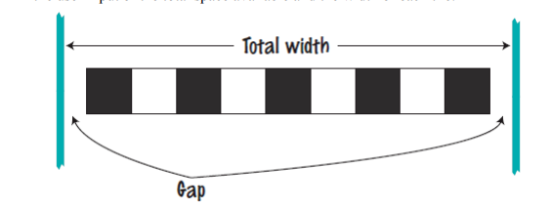

1. A row of black and white tiles needs to be placed along a wall. For aesthetic reasons, the architect has specified that the first and last tile shall be black.

2. Your task is to compute the number of tiles needed and the gap at each end, given the user input of the total space available and the width of each tile.

**Design**

**Inputs**

TotalWidth – float

TileWidth – float

**Outputs**

NoofTiles - int

Space – float

**Algorithm**

1. Ask the user for the inputs and read the individual inputs.
2. Calculate the number of full tiles that fit into the total width.
3. If the number of tiles is even – then subtract one from the total number of tiles.
4. Calculate the space at either end
   1. Space = (Total Width – TiledWidth)/2
5. Output the results to the user.

**Code**

#ifdef _MSC_VER

#define _CRT_SECURE_NO_WARNINGS

#endif

/*

Name naqi ahmad

Program Description black and white tiles needs to be placed along a wall.

*/

#include<stdio.h>

#include<conio.h>

void main()

{

//Declare Variables

float tilewidth, width, space;

int no_tiles;

float tiledspace;

// Prompt user and read the input

printf("Please enter the tile width, total width in the following format - 1 100 \n");

scanf("%f %f", &tilewidth, &width);

//Calculate the integer number of tiles

no_tiles = width / tilewidth;

// Test to ensure odd no of tiles

if (no_tiles % 2 == 0)

no_tiles = no_tiles - 1;

// Calculate the total area of tiles

tiledspace = tilewidth * no_tiles;

//Calculate the space

space = (width - tiledspace) / 2;

//Output the results

printf("The number of tiles is %d and the space at either end is %.2f", no_tiles, space);

getch();

}

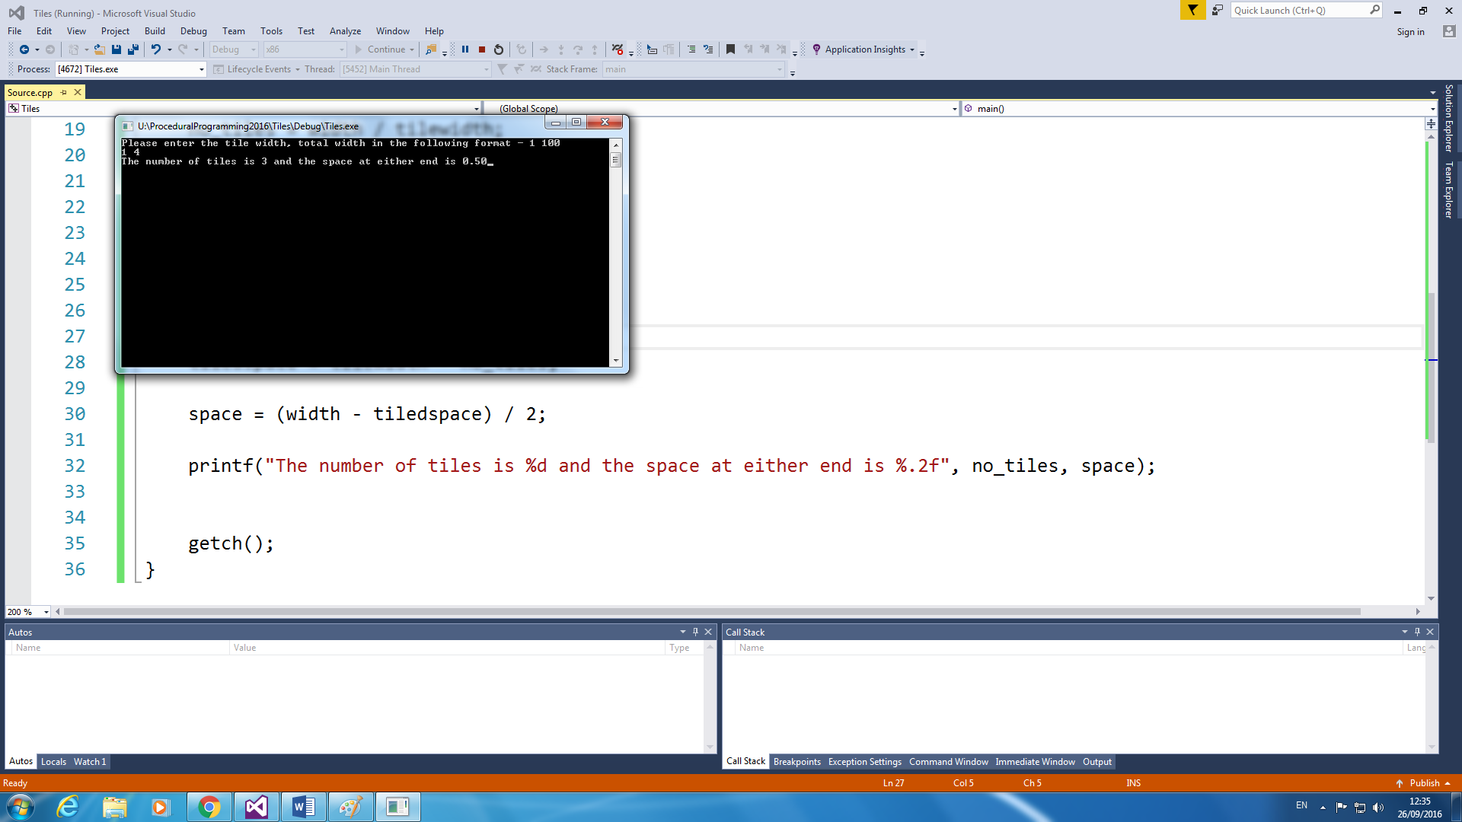

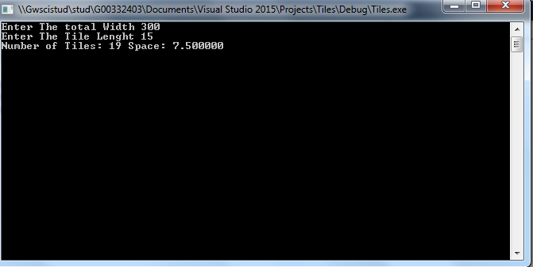

**Part 2**

Name NAQI Ahmad

ID G00332403

Email [G00332403@gmit.ie](mailto:G00332403@gmit.ie)

For this part of the lab you will write a program in C that calculates a student’s result from a course. Your code should read in three percentages representing their marks for assignment, a lab exam and a written exam. It should then calculate their overall result. The exam counts for 60% of the marks, the lab exam 10% and the assignment 30%. Finally, it should display their overall mark as a percentage and the appropriate grade from the following table:

**Mark Grade**

|  |  |
| --- | --- |
| 70+ | A |
| 60-69 | B |
| 50-59 | C |
| 40-49 | D |

**Design**

**Inputs**

//constant Float- FINAL_EXAM = 0.60;

//constant Float- LAB_EXAM = 0.10;

//constant Float- ASSIGNMENT_EXAM = 0.30;

Float- finalExam;

Float- labExam;

Float- assignment;

**Outputs**

Float - average;

Char - grade;

**Algorithm**

1. Ask the user for the inputs and read the individual inputs.
2. Calculate the average by multiplying by the marks(input).
3. Printout the overall average.
4. Use if statements to get the grade.
5. Output the results to the user (Average + grade of the user).

**Code**

/*Name NAQI AHMAD

Calculate the average of the marks and display grades and overall all percentage

*/

#include<stdio.h>

#include<conio.h>

void main()

{

//Declare Variables

float finalExam, labExam, assignment, average;

const float FINAL_EXAM = 0.60, LAB_EXAM = 0.10, ASSIGNMENT_EXAM = 0.30;

char grade = ' ';

// Prompt user and read the input

printf("Enter the Grades For Final Exam & Lab Exam & Assignment: ");

scanf("%f %f %f", &finalExam, &labExam, &assignment);

//Calculate the Average

average =((finalExam * FINAL_EXAM)+ (labExam * LAB_EXAM) + (assignment * ASSIGNMENT_EXAM));

printf("Your Overall Mark is: %f ",average);

//use if statements to calculate the grade

if (average < 40)

{

grade = 'E';

}

else if (average >= 40 && average <50)

{

grade = 'D';

}

else if (average >= 50 && average <60)

{

grade = 'C';

}

else if (average >= 60 && average <70)

{

grade = 'B';

}

else if (average >= 70)

{

grade = 'A';

}

//Output the results

printf("Your Grade Is: %c",grade);

getch();

}

**Pictures next page**

